1. Introduction to the AC Power Clamp
An AC Power Clamp (often known simply as a clamp meter or current clamp) is an instrument designed to measure the current (and by extension, power) in an AC conductor without the need to make a direct electrical connection. It works by sensing the magnetic field produced by the current in the conductor and, through a current transformer (CT) or Hall Effect sensor, converting that magnetic field into a measurable electrical signal.

Key Functions and Applications
- Non-Invasive Measurement: By simply clamping around a conductor, the device measures current without breaking the circuit.
- AC Current and Power Measurement: When combined with voltage measurement (or by knowing the voltage level), the clamp meter can compute real power, apparent power, and even reactive power.
- Safety and Convenience: Since no direct contact with live high-voltage circuits is needed, measurement is safer and more convenient.
- Lab and Field Use: Commonly used in educational labs and industrial settings, it demonstrates principles of transformer action, electromagnetic induction, and AC power analysis.
2. Working:-
- Complete Component Picture:-
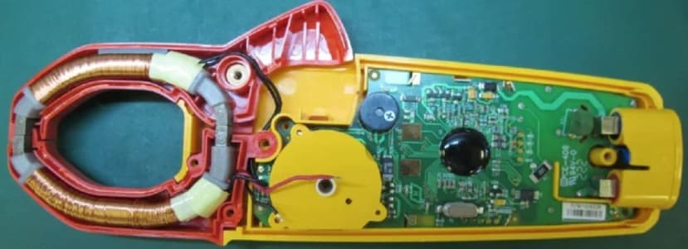

2.1 Sensing the Magnetic Field
When alternating current (AC) flows through a conductor, it produces a magnetic field that oscillates at the same frequency as the current. When the clamp's 'jaws' are placed around a conductor carrying ac current, the current is coupled through the jaws, which in turn is connected across the shunt of the meter's input, this is a similar process to that of an iron core in a power transformer passing current into a secondary winding. The current transformer in a clamp meter provides a real-world application of transformer equations, showing how magnetic coupling translates currents from one circuit to another.
The current delivered to the meter's input (across the shunt) is a much smaller current and is a ratio of the number of secondary windings vs. the number of primary windings wrapped around the core. Normally the 'primary' is the conductor being measured (which the jaws are clamped around), so if the secondary has 1000 windings, then the secondary current is 1/1000 the current flowing in the conductor being measured. An AC Power Clamp typically uses one of two methods to sense this field:
- Current Transformer (CT) Method:
The clamp acts as the secondary winding of a transformer, with the conductor passing through its magnetic core acting as the primary winding. The induced current in the secondary winding is proportional to the primary current (scaled by the turns ratio), which can then be measured across a burden resistor.
- Hall Effect Sensor Method:
A Hall effect sensor detects the magnetic field directly. These sensors generate a voltage proportional to the magnetic field strength and can measure both AC and DC currents (although many clamp meters are designed specifically for AC measurement).
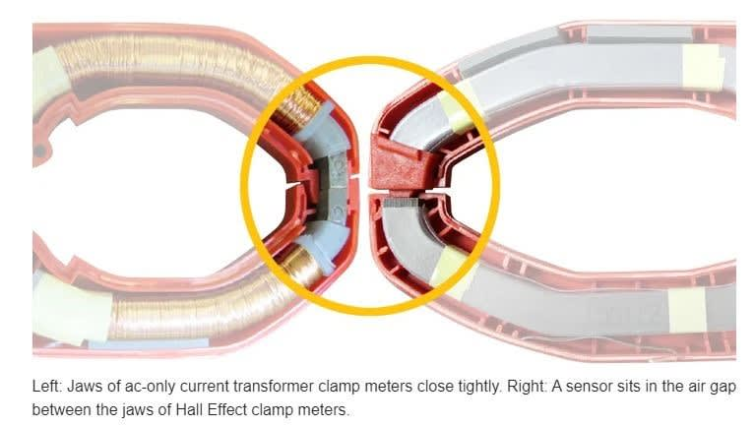

2.2 Signal Conditioning and Processing
After the initial sensing, the weak signal (voltage across the burden resistor or from the Hall sensor) typically undergoes further processing:
- Amplification:
Low-level signals may be amplified using precision amplifiers.
- Filtering:
To reduce noise, signal filtering (both low-pass and band-pass) is often used so that the AC waveform is cleanly processed.
- Rectification and RMS Conversion:
Because AC power calculation requires the effective (RMS) value, a rectifier circuit and RMS-to-DC converter or digital signal processing techniques are implemented. After the current is sensed and converted into a small AC voltage across the burden resistor, rectification is done in the analog domain, right before or as part of the RMS converter. Once the signal is rectified, the RMS-to-DC converter outputs a DC voltage corresponding to the effective value (root mean square) of the AC signal.
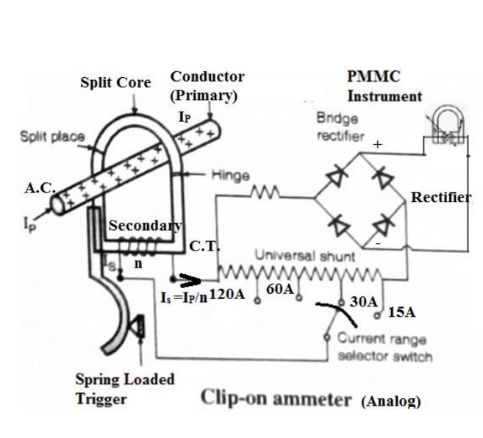
- Analog-to-Digital Conversion (ADC):
In modern clamp meters with digital readouts, the conditioned analog signal is converted to digital form for further processing and display.

Below is a schematic-style breakdown of the internal circuitry found in an AC Power Clamp designed for AC current measurement (using the current transformer method). Each block is explained relative to its role and associated course concepts.

AC Conductor
↓
┌───────────────────────────┐
│ Magnetic Clamp (CT) │
└───────────────────────────┘
↓
Burden Resistor
↓
Signal Conditioning (Amplification + Filtering)
↓
┌────────────────┐
│ Analog Signal │
└────────────────┘
↓
┌────────────────────┐
│ ADC (Analog to │
│ Digital Converter) │
└────────────────────┘
↓
┌────────────────────┐
│ Microcontroller / |
│ Digital Processor |
└────────────────────┘
↓
Digital Display

3. Detailed Circuit Description

3.1 Current Transformer (CT) Stage
- Operating Principle:
The current transformer operates on electromagnetic induction. When the AC current (primary) flows through the conductor (which acts as a single-turn primary), it induces a proportional current in the secondary winding wrapped around a high-permeability magnetic core.
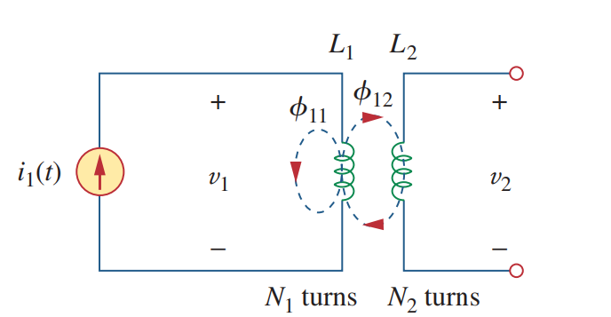
- Transformer Equation:
Ip × Np = Is × Ns
Where:
  - Ip is the primary current,
  - Np​ is the effective number of primary turns (usually 1),
  - Is​ is the secondary current,
  - Ns is the number of turns in the secondary winding.
This equation is covered under transformer theory in AC circuit analysis.

3.2 Burden Resistor
- Function:
The burden resistor is connected across the secondary winding. Its purpose is to convert the secondary current Is into a voltage V_{b}​ proportional to the current:
V_{b} = I_{s} × R_{b}
- Design Considerations:
The resistor must be chosen to ensure that the voltage remains within measurable limits and does not load the transformer excessively. This design aspect is tied to the principles of impedance matching and power transfer.

3.3 Signal Conditioning and Amplification
- Amplifier Stage:
Since V_{b}​is usually small, an operational amplifier (op-amp) configuration is used to boost the signal to a level suitable for further processing.
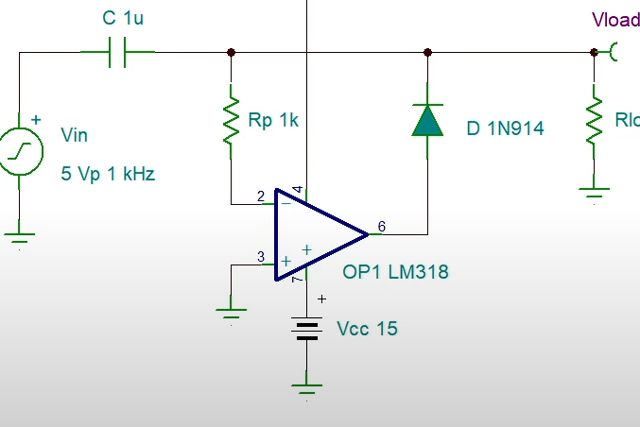
- Filtering:
An active or passive filter (often low-pass) removes high-frequency noise and harmonics, ensuring that the resulting signal accurately represents the fundamental AC waveform.
- Phase Considerations:
Care is taken that the conditioning circuitry preserves the phase of the original signal, which is critical for accurate power calculations.

3.4 RMS Conversion / Digital Signal Processing
Analog RMS Conversion:
In analog systems, dedicated RMS-to-DC converter circuits provide a DC output proportional to the root-mean-square value of the AC signal. ADC and Microcontroller converts the conditioned analog signal into digital form. The microcontroller then performs computations such as RMS calculation, phase detection, and power factor determination. The Root Mean Square (RMS) value of a voltage or current waveform is defined mathematically as:
V_{RMS}=$\sqrt{\frac{1}{T}\int_{0}^{T}{{\left[V\left(t\right)\right]}^{2}dt}}$
Where:
- V_{RMS}​is the RMS voltage.
- V (t) is the instantaneous voltage as a function of time.
- T is the period of the waveform (for periodic signals) or a sufficiently long time interval (for non-periodic signals).

  - Diagram of RMS-to-DC converter circuit:-
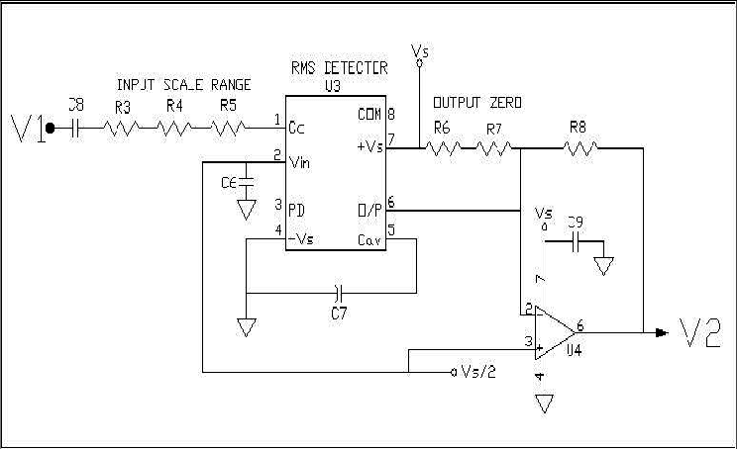
- Digital Processing:
Alternatively, if an analog-to-digital converter (ADC) is incorporated, the waveform is sampled, and a microcontroller processes the data to compute the RMS value using digital algorithms.
- Relevance to Course:
This stage reinforces concepts from AC analysis where accurate RMS calculation is essential in power measurements.

4. RMS and Power Calculations

a. Current Measurement
- Current is measured using a current transformer (CT) and a burden resistor.
- The voltage across the burden resistor is proportional to the instantaneous current.

b. Voltage Measurement
- A voltage probe or divider circuit measures the instantaneous voltage on the same conductor.
Both signals are analog and must be digitized by separate ADCs.
c. Power Calculations
- RMS Values:
Accurate RMS determination is vital to compute effective power. The conversion of the raw AC signal to its RMS equivalent is directly connected to the analysis of sinusoidal functions—an integral part of AC circuit theory.
- Power Calculations:
Using the measured current alongside known or measured voltage, the clamp meter aids in calculating:
  - Apparent Power (S): S = V_{RMS.} I_{RMS}
  - Real Power (P): P= V_{RMS.} I_{RMS.} $\cos{∅}$
  - Reactive Power (Q): Q= V_{RMS.} I_{RMS}. $\sin{∅}$
These computations consolidate theory from AC power analysis.

d. Power Factor (PF)
This tells you how "real" the power is — i.e., how much of the apparent power is being actually used (real power).
PF= $\frac{Pavg}{S}$ = cos (ϕ)
A value near 1.0 means efficient power usage; a lower value means a lot of reactive (useless) power is circulating.

